**Exp.No. :1 Name :Prasanna R**

**Date:31/7/2024 Reg.no.:231701039**

**Aim:**

To develop and design a mobile or web application to change background and menus.

**Procedure :**

1) Open figma (either login or continue whith google chrome ).

2) Open a new file.

3) Then select the sze of the frame.

4) Insert the background image and reduce its compostioion thus it doesn’t affect the other elements.

5) Insert the required elements in to the design i.e text,images,symbols,shapes etc.

6) Save your design .

**Before:**

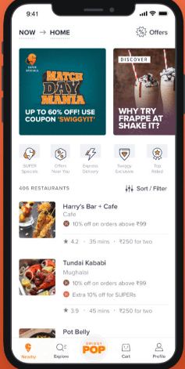

**After:**

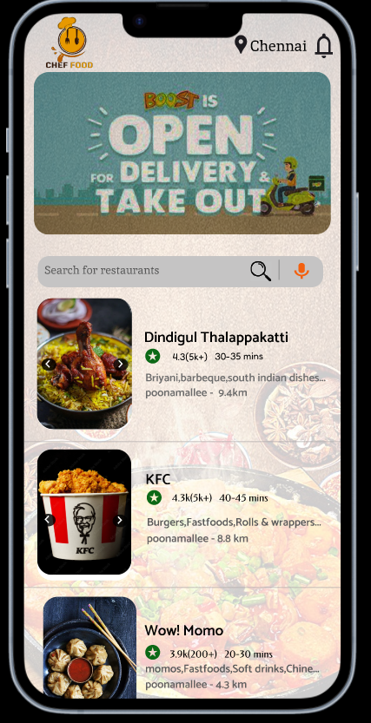

**Result:**

Thus the design for mobile or web application to change background and menus had been developed using figma .